**PIZZA_SALES**

Kpi Requirement

1. Total revenue

-- select total no pizza sales

select sum(total_price) as total_revenue

from pizza_sales ;

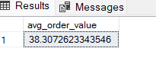

1. Avg order value

select sum(total_price) / count(distinct order_id) as avg_order_value

from Pizza_sales ;



1. Total pizza sold

-- Total Quantity of pizzas sold

select sum(quantity) as total_pizza_sold

from pizza_sales ;

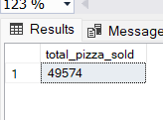

1. Total order till

-- total order placed

select count(distinct order_id ) as total_order_placed_till_now

from pizza_sales

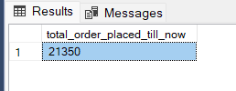

Inside : for every order we have sold double pizza

5)Avg pizza per order

--- avg pizza per order

select sum(quantity) / count(distinct order_id) as avg_pizza_sold_per_order

from pizza_sales

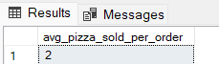

Charts Requirement

daily Trend for orders

--- Daily Trend for total order per day

select DATENAME(DW , order_date) as order_day , count(distinct order_id) as total_orders_per_day

from pizza_sales

group by DATENAME(DW , order_date) ;

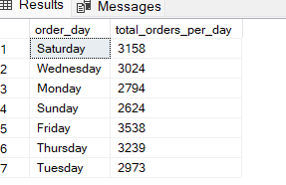

Hours trends for order

--- hourly sales trend of pizza

select datepart(hour,order_time) as orders_hours , count(distinct order_id) as total_order_per_hours

from pizza_sales

group by datepart(hour,order_time)

order by datepart(hour,order_time) asc ;

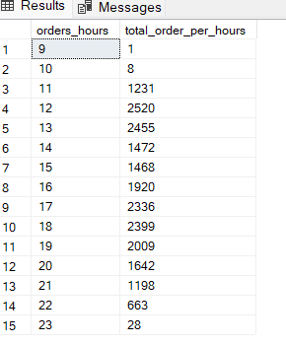

monthly trend for sales order

SELECT

DATEPART(YEAR, order_date) AS order_year,

DATEPART(MONTH, order_date) AS order_month,

COUNT(DISTINCT order_id) AS total_orders_per_month

FROM

pizza_sales

GROUP BY

DATEPART(YEAR, order_date),

DATEPART(MONTH, order_date)

ORDER BY

order_year,

order_month;

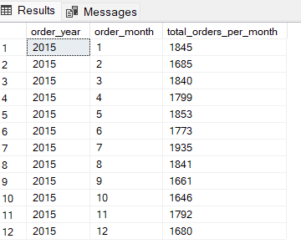

Percentage of sales of Pizaa Category

select pizza_category , round(sum(total_price),2)as total_sales , round(sum(total_price)* 100 / (select sum(total_price) from pizza_sales),2) as total_sales_percentage

from pizza_sales

group by pizza_category

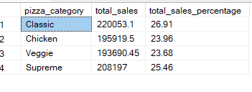

If You want to find he sales of per pizza category wrt to particular month then sol :

--- wrt particular month(octomber)

select pizza_category , round(sum(total_price),2)as total_sales_octomber , round(sum(total_price)* 100 / (select sum(total_price) from pizza_sales),2) as total_sales_percentage_for_octomber

from pizza_sales

where month(order_date)= 10

group by pizza_category

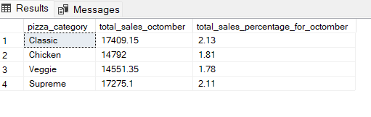

Similarly we can try some other query

-- daily week dayas of sales trend in month of february

select DATENAME(DW , order_date) as order_day , count(distinct order_id) as total_orders_per_day

from pizza_sales

where month(order_date)= 2

group by DATENAME(DW , order_date) ;

--- hourly sales trends of pizza where in month of january

select datepart(hour,order_time) as orders_hours , count(distinct order_id) as total_order_per_hours

from pizza_sales

where month(order_date)= 1

group by datepart(hour,order_time)

order by datepart(hour,order_time) asc ;

--- here it is total oreder in the 4th quarter

select DATENAME(DW , order_date) as order_day , count(distinct order_id) as total_orders_per_day

from pizza_sales

where datepart(QUARTER,order_date)= 4

group by DATENAME(DW , order_date) ;

-- top 5 best selller total pizzas sold

select top 5 pizza_name ,sum(quantity) as total_quantity

from pizza_sales

group by pizza_name

order by sum(quantity) desc ;

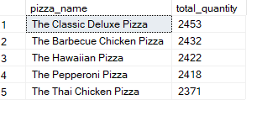

---Bottom 5 best selller total pizzas sold

select top 5 pizza_name ,sum(quantity) as total_quantity

from pizza_sales

group by pizza_name

order by sum(quantity) ;

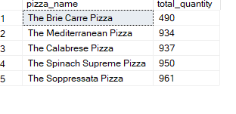

top 5 total order total of pizzas sold

SELECT Top 5 pizza_name, COUNT(DISTINCT order_id) AS Total_Orders

FROM pizza_sales

GROUP BY pizza_name

ORDER BY Total_Orders DESC

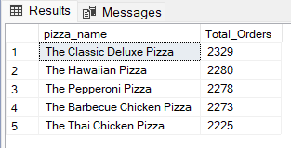

Bottom 5 total order of total pizzas sold

SELECT Top 5 pizza_name, COUNT(DISTINCT order_id) AS Total_Orders

FROM pizza_sales

GROUP BY pizza_name

ORDER BY Total_Orders ASC

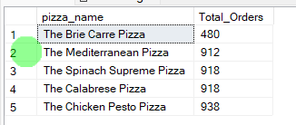

how much sales is there in in hour time for a year with respect to category of pizza

select datepart(hour,order_time) as time_sale ,pizza_category, round(sum(total_price),2) as total_sale , round(sum(total_price)*100/(select sum(total_price) from pizza_sales),2) as total_percent_of_sale_by_size

from pizza_sales

group by datepart(hour,order_time) , pizza_category

order by time_sale

time category total_sale total_%_of_sale_by_size

9 Supreme 20.75 0

9 Classic 42 0.01

9 Veggie 20.25 0

10 Supreme 53.5 0.01

10 Chicken 125.25 0.02

10 Classic 89 0.01

10 Veggie 35.9 0

11 Supreme 11762.65 1.44

11 Classic 12778.85 1.56

11 Chicken 10466.25 1.28

11 Veggie 9928.05 1.21

12 Supreme 28282.85 3.46

12 Chicken 26232 3.21

12 Veggie 27426.2 3.35

12 Classic 29936.85 3.66

13 Supreme 26755.65 3.27

13 Veggie 25121.15 3.07

13 Classic 28714.9 3.51

13 Chicken 25474 3.11

14 Chicken 14243 1.74

14 Veggie 13921.75 1.7

14 Supreme 14959.2 1.83

14 Classic 16077.45 1.97

15 Veggie 12500.95 1.53

15 Supreme 14107.95 1.72

15 Chicken 12656.25 1.55

15 Classic 13727.15 1.68

16 Veggie 16473.45 2.01

16 Classic 19120.95 2.34

16 Chicken 16751.5 2.05

16 Supreme 17709.5 2.17

17 Classic 23674.45 2.89

17 Veggie 19978.15 2.44

17 Chicken 20843.75 2.55

17 Supreme 21741.1 2.66

18 Veggie 21012.05 2.57

18 Classic 24211 2.96

18 Chicken 21453 2.62

18 Supreme 22620.8 2.77

19 Classic 18755.95 2.29

19 Veggie 17450.4 2.13

19 Chicken 17374.25 2.12

19 Supreme 19048.3 2.33

20 Classic 15518.9 1.9

20 Veggie 14470.45 1.77

20 Supreme 14220.55 1.74

20 Chicken 14005.5 1.71

21 Veggie 9722.65 1.19

21 Classic 11373.7 1.39

21 Chicken 10364.5 1.27

21 Supreme 10568.95 1.29

22 Veggie 5317.7 0.65

22 Supreme 5981.25 0.73

22 Chicken 5683 0.69

22 Classic 5833.2 0.71

23 Chicken 247.25 0.03

23 Veggie 311.35 0.04

23 Supreme 364 0.04

23 Classic 198.75 0.02

**PowerBI Analysis**